**DAILY ONLINE ACTIVITIES SUMMARY**

|  |  |  |  |  |  |  |  |
| --- | --- | --- | --- | --- | --- | --- | --- |
| **Date:** | **16/06/2020** | | | | **Name:** | **Syed Rabeya Aamir** | |
| **Sem & Sec** | **8th B** | | | | **USN:** | **4AL16CS112** | |
| Online Test Summary | | | | | | | |
| **Subject** | | **BDA** | | | | | |
| **Max. Marks** | | **30** | | **Score** | | **24** | |
| Certification Course Summary | | | | | | | |
| **Course** | **AUTOMATIC MODEL TUNING IN AMAZON SAGEMAKER.** | | | | | | |
| **Certificate Provider** | | | **Aws** | **Duration** | | | **6 hrs** |
| Coding Challenges | | | | | | | |
| **Problem Statement:**  **1) Python Program for compound interest.** | | | | | | | |
| **Status: Solved** | | | | | | | |
| **Uploaded the report in Github** | | | | **YES** | | | |
| **If yes Repository name** | | | | **rabeya** | | | |
| **Uploaded the report in slack** | | | | **YES** | | | |

**Online Test:**

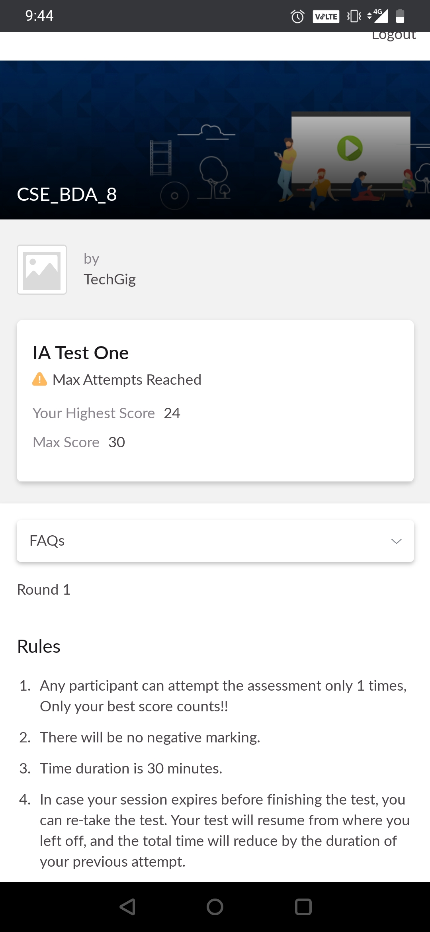

**Certification Course Details:**

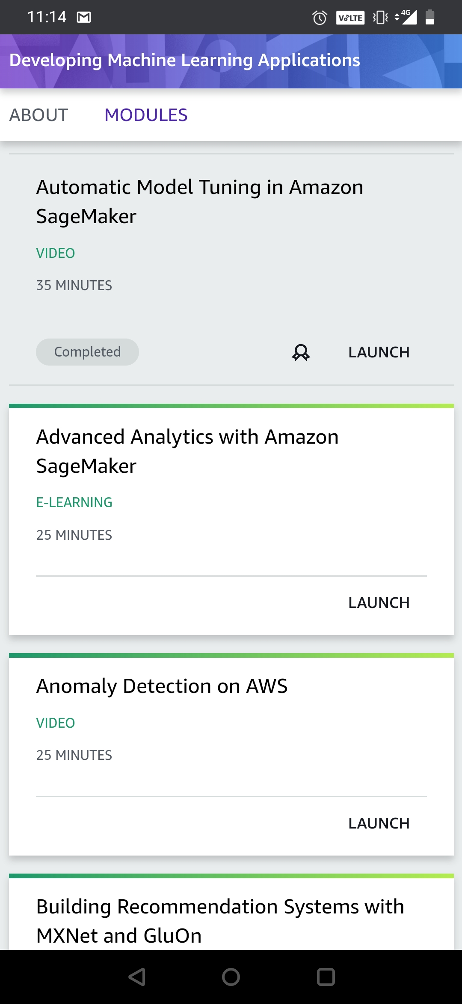

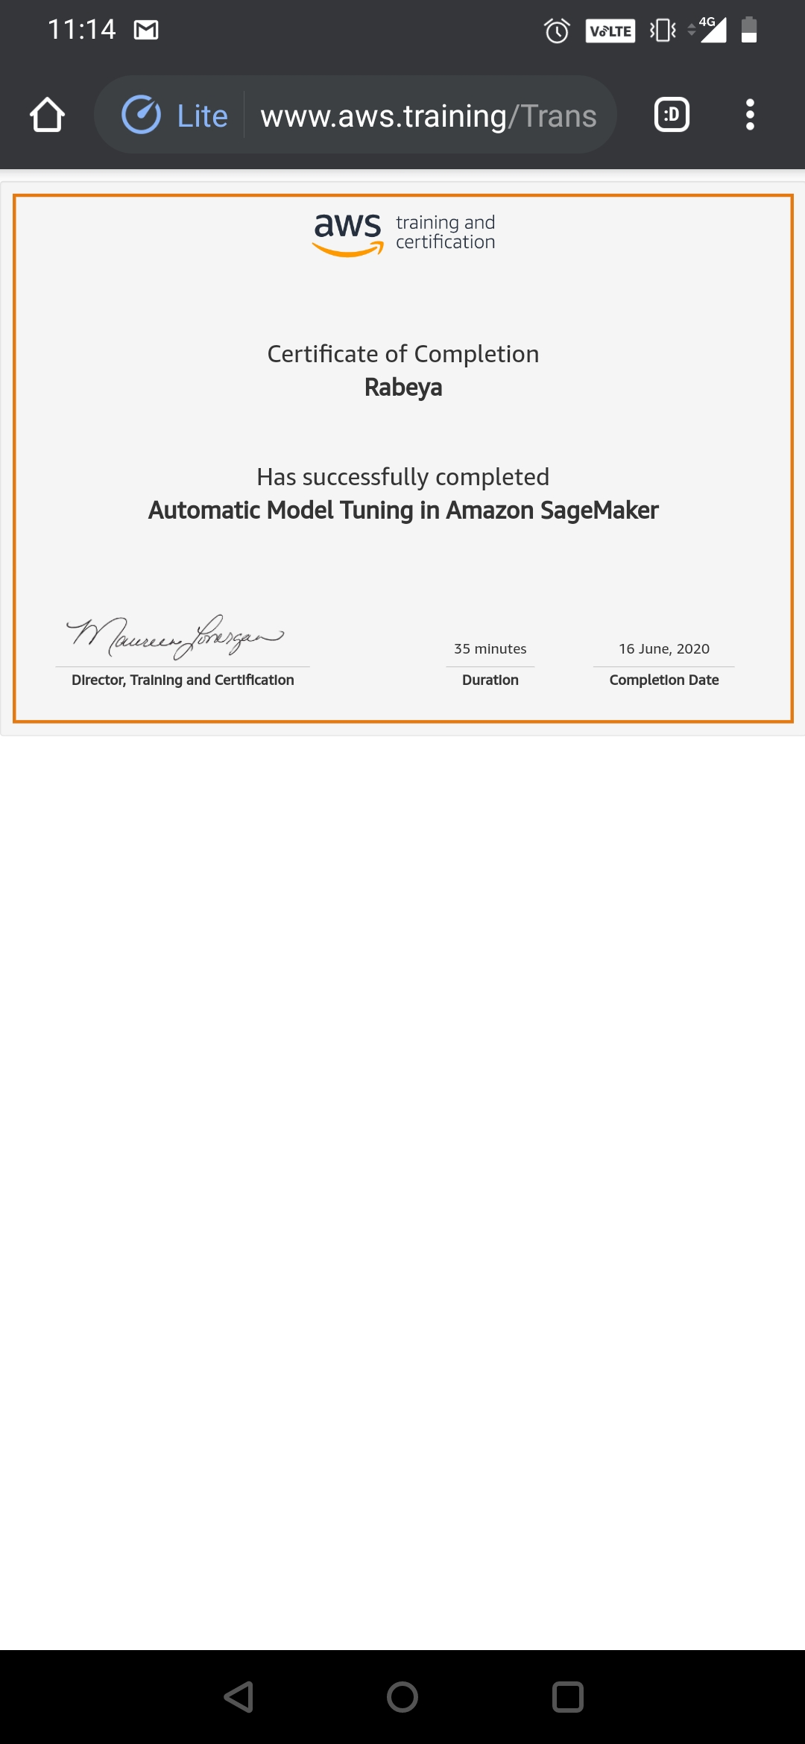

# CODE:

Program no:1

# Python Program for compound interest.

def compound_interest(principle, rate, time):

# Calculates compound interest

CI = principle * (pow((1 + rate / 100), time))

print("Compound interest is", CI)

# Driver Code

compound_interest(10000, 10.25, 5)